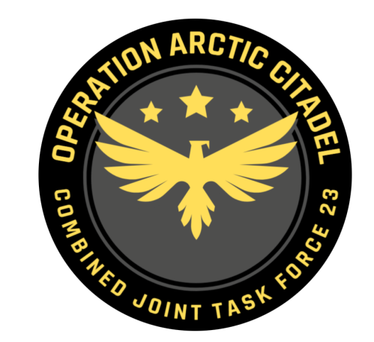

Joint Force Commander CJTF-23

DIRECTION AND GUIDANCE

D7
This document covers the friendly situation from D6 and provides CJTF-23 guidance to the entire force for D7.
Reference CombatFlite: https://132nd-vwing.github.io/OPAC-Brief/SITUATION/Friendly%20Situation.cf

SITUATION

General situation
Road to war according to introduction brief: Operation Arctic Citadel Introduction Brief

D0: September 20th 2011:
JFACC initiated intelligence gathering related to the situation, and completed phase 1 (Deployment) into theater. LCC started deployment of IV Corps into Finland and are continuing force buildup.

D1: September 21st 2011:
JFACC initiated deterrence of Notian forces, but deterrence was unsuccessful. SEAD/DEAD conducted toward high-end SAMs in 1st and 3rd Corps area, while conducting attacks at HQs as part of slowing down enemy advance.
LCC moved into contact with Notian forces at the end of D1 at three locations.

D2: September 22nd 2011:
JFACC moved into phase 3a: Defence of Notia and established CAPs to protect the airspace from Notian incursions. In addition the CAPs protected friendly ground forces and airbases from Notian attacks. JFACC also initiated AR and CAS flights to support against Notian ground forces moving into Finland. JFACC also executed SEAD/DEAD and BAI to shape for further action.
D3: September 23rd 2011:
JFACC continued shaping the battlefield by using CAPs to establish air superiority, SEAD/DEAD against enemy forces in Finland, combined with strike against communication in Notia while at the same time support the ground forces by AR and CAS against Notian forces in Finland.
MCC have moved CVN to CVOA during D3 and are ready for operations on D4.
LCC have continued ground defensive operations in Finland.

D4: September 24th 2011:
JFACC have started shaping in Notian territory by attacking Notian strategic SAMs:
JFACC have also degraded Notian offensive ability by attacking 2nd Corps HQ and 3rd Corps HQ.
JFACC have also started striking Notian war production (Apatite Radar Factory).
MCC have started carrier operations from CVOA.
LCC have continued ground defensive operations in Finland withdrawing from IVALO.

D5: September 25th 2011:
MCC have flown CAP and built situational awareness on the surface. MCC have supported JFACC in doing AR against Notian ground forces in Finland.
LCC have continued ground defensive operations in Finland. IVALO now completely lost.

D6: September 26th 2011:
MCC have flown CAP, defended maritime assets and built situational awareness on the surface. MCC have supported JFACC in doing AR against Notian ground forces in Finland and Notia.
LCC have continued ground defensive operations in Finland. Prepared for counteroffensive.

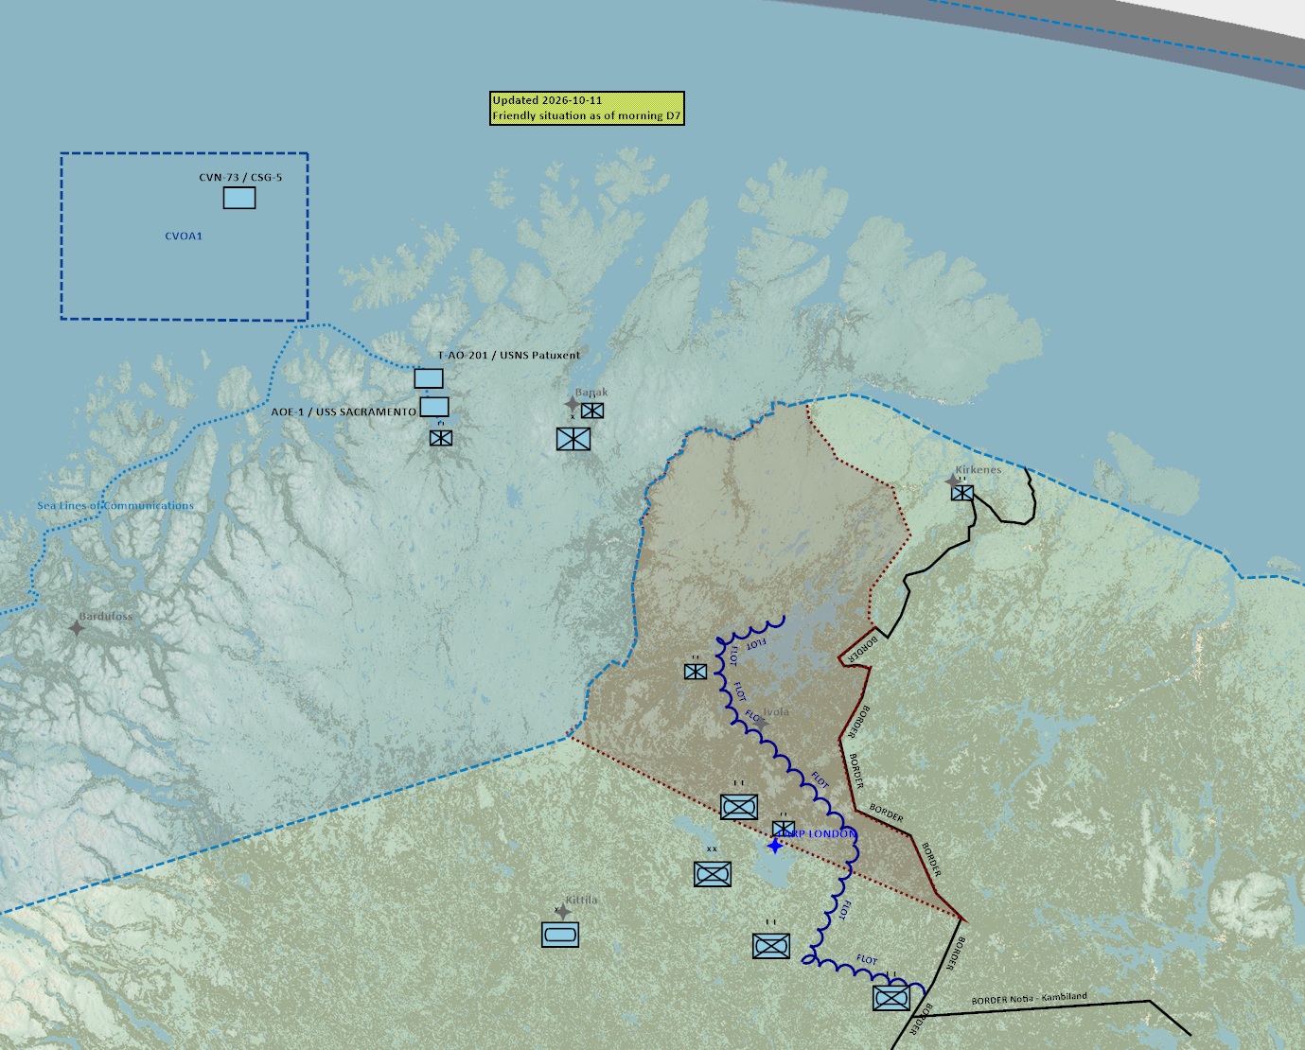

Reference CombatFlite: https://132nd-vwing.github.io/OPAC-Brief/SITUATION/Friendly%20Situation.cf

Friendly situation

Land Component Command (LCC)

IV Corps

55th Armor Division (Abrahams and Challenger 2 tanks) (No change)
Currently in reserve located around Kittila.

56th Mechanized Division (M2A2 Bradley, LAV-25 and Humwee’s)
Lead elements of the 56th Division have established contact with the enemy in three locations:
BN 1: Located SOUTH of IVALO. Currently defensive and under pressure. (No change)
BN 2: West of Lokka (No change)
BN 3: Northwest of the border between Notia, Kambiland and Finland (No change)

Finnish local forces (no change)
- The Finnish 33rd Brigade (M-113s)
- First BN –Withdrawn to Inari.
- Second BN- located IVO FARP LONDON.

Norwegian local forces (no change)
- The Norwegian 44th Brigade (M-113s, Leopard and Bradley)
- First BN (Bradley IFV) – Located IVO Kirkenes
- Second BN (M113 APC) – Located IVO Banak
- Third BN (Leopard MBT – Located IVO Alta

Maritime Component Command (MCC)
- CVN-73/CSG-5 supported operations from CVOA1 on D4.
- Two support ships have arrived in Bodø (USS Sacramento (AOE-1) and USNS Patuxent (T-AO-201). These ships will be used for logistical operations and are a high value unit.

Special Operations Component Command (SOCC)
- SOF teams are standing by to support with reconnaissance as required.
- SOF teams are also on standby to conduct counter terrorism missions and counter insurgency operations.

Reported Battle Damage Assessment

IV Corps Northern Sector
- 1x Main Battle Tanks

Finnish local forces.
- 2x BMP-3

Norwegian local forces.
- NSTR

Logistical situation
Available ordnance: https://132nd-vwing.github.io/OPAC-Brief/MISSION%20INFORMATION/OPAC%20Ordnance.pdf

Direction and Guidance

General (CHANGE D7)
- CJTF-23 is now ready to go onto the offensive. All component commanders are tasked to execute offensive operations.
- Commander CJTF-23 primary concern are Notian air assets that interrupt operations, and Notian factories producing air defence assets. If we do not start taking these out, Notia will have a continuous flow of SAM’s available.

LCC:
- Start counteroffensive using IV Corps to retake territory lost in Finland. (CHANGE D7)
  - First objective IVALO. (CHANGE D7)

MCC:
- Assume responsibility for MCC Area of Responsibility(AOR)
- Support the campaign with embarked airwing.
  - Provide 1-2 flights for JFACC for support in JFACC Area of Responsibility (AOR)
- Protect maritime assets from attacks from enemy
  - USS George Washington (CVN-73) operating in CVOA 1 (or new CVOA)
  - USNS Patuxent (T-AO-201) is enroute CVN-73 from Bodø and will replenish CVN-73 George Washington with aviation fuel on completion of D6.
  - USS Sacramento (AOE-1) is enroute Alta with ordnance for Banak, Kittila and Rovenemi airbase before rearming CVN-73 on completion of D7. Enroute from Bodø morning hours on D6.

JFACC:
- Assume responsibility of JFACC Area of Responsibility (AOR)
- Apportionment
  - Per JFACC priorities
  - A-10s and RW are to support LCC offensive. Other assets are prioritized to offensive action. (CHANGE D7)
- JFACC are now in phase 3b DECISIVE ACTION (CHANGE D7)
- Priority of effort is for JFACC to be able to take the fight to the enemy territory so the enemy need to balance protection of own territory against the offensive action in Finland.
  - With ground forces heavily engaged in Finland, the only offensive assets available to take the fight to the Notian homeland for the Combined Joint Task Force is JFACC air assets.

VIS:
- Support JFACC with planning and execution of campaign.
  - Be prepared to support JFACC with phase 3b planning.
- Recommend to JFC changes in diplomatic status for any country during target meeting.

Diplomatic situation
- Notia is declared as enemy
- Kambiland is declared as neutral
- Xilong is declared as enemy (CHANGE D7)
- DUSS is declared as adversary
- The Iron Resolve is declared as enemy
- The Dawn’s Vengeance is declared as adversary

Only units declared as enemy can and should be engaged by CJTF forces.

Definitions:
Enemy: is actively opposed or hostile to CJTF and friendly forces.
Adversary: opponent in a contest, conflict, or dispute toward CJTF and friendly forces.
Neutral: not supporting or helping either side in a conflict, disagreement, etc.; impartial.

Joint Force Air Component Commander – Commander of all air forces (player volunteers)
Land Component Commander – Commander of all land forces
See CombatFlite: https://132nd-vwing.github.io/OPAC-Brief/SITUATION/Friendly%20Situation.cf
All area not MCC AOR. See 3 above.
Air apportionment is the determination and assignment of the total expected effort by percentage and/or priority that should be devoted to the various air operations and/or geographic areas for a given period of time.

